Virgin Mobile KSA App (Customer Account)
This document provides a comprehensive and formal explanation of the features and user interface of the Virgin Mobile KSA application. Each section of the app is described in detail, with accompanying screenshots for clarity. The flow starts from the Home Page and navigates through the app's key functionalities, including payment setup, usage monitoring, and support features.

1. Home Page (الصفحة الرئيسية)

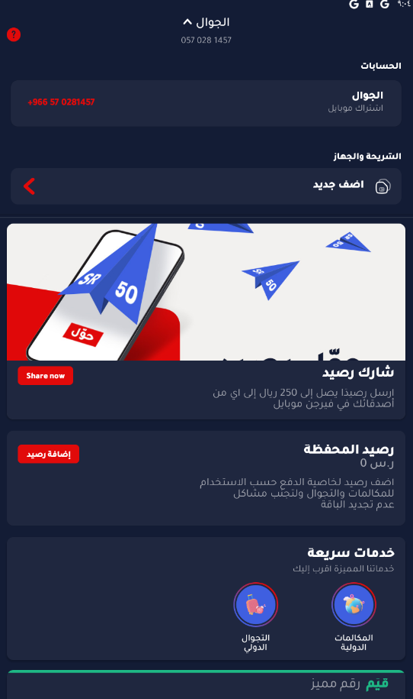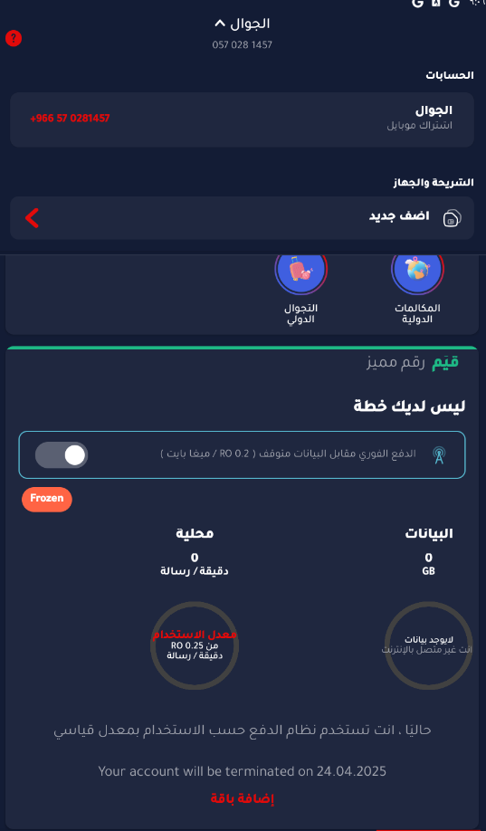
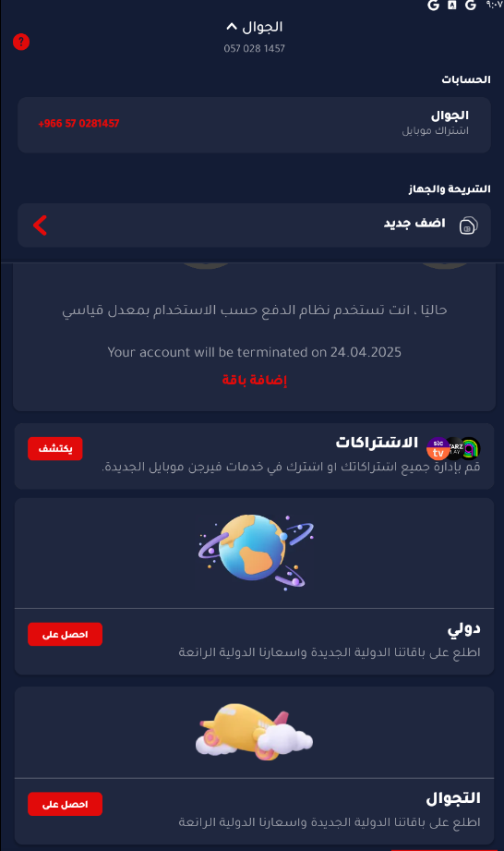

The Home Page is the central hub of the Virgin Mobile KSA app, displaying the primary account information and quick access to essential services.
Key Features:
- Mobile Number: Displays the active mobile number associated with the account.
- Share Balance: Enables the user to share up to 250 SAR with other Virgin Mobile users.
- Wallet Balance: Shows the current wallet balance and provides an option to add credit.
- Quick Access Services: Includes icons for International Roaming and International Calls.
- Plan Information: Displays whether the user has an active plan. If no plan is active, usage is calculated per MB or per minute. It also includes an option to toggle data usage and shows the 'Frozen' status if no balance or plan is available.
- Account Validity: A warning is shown if the account is approaching termination, with the option to renew or add a bundle.

2. Payment Method (إعداد طريقة الدفع)

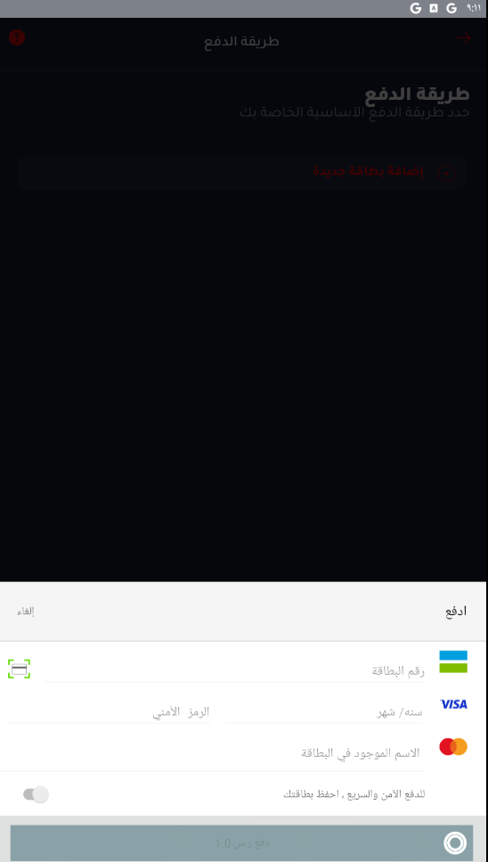
This section allows the user to securely add and manage payment methods.
Key Features:
- Card Entry Fields: The user is required to enter the card number, expiry date, CVV (security code), and the name as printed on the card.
- Save Card Option: Toggle to save the card for future payments.
- Supported Cards: The interface supports VISA and MasterCard.
- Pay/Cancel Options: Users can choose to proceed with the payment or cancel the process.

3. Payment Preferences (خيارات الدفع والشحن)

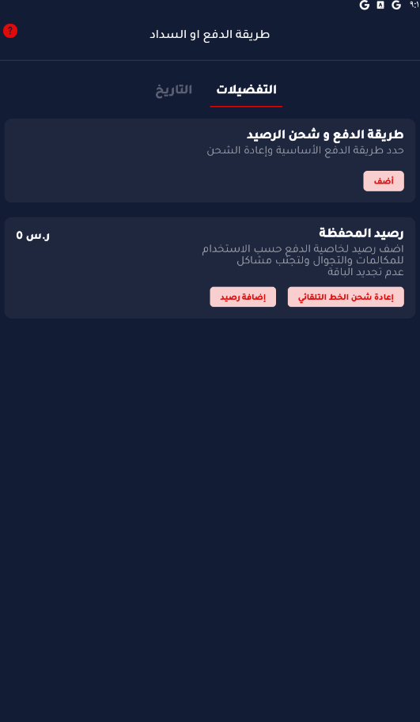
This area allows users to manage their recharge preferences and stored wallet balance.
Key Features:
- Set Primary Payment Method: Users can define the default method for recharging.
- Wallet Overview: Displays the current wallet balance (0 SAR in the sample).
- Recharge Controls: Users can add balance manually or automate balance recharge.

4. Usage History (سجل الاستخدام)
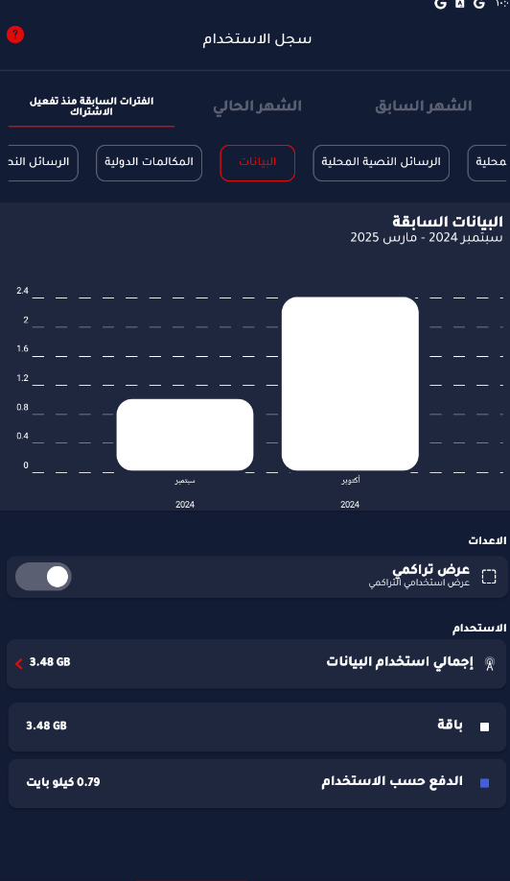
This section provides a breakdown of the user’s activity over different categories and time periods.
Key Features:
- Data Usage Overview: Visual graph showing data used per month.
- Category Tabs: Includes local and international calls, SMS, and data usage.
- Cumulative View Toggle: Option to switch between monthly and cumulative data.
- Detailed Breakdown: Lists the total data usage via plan or pay-as-you-go method.

5. Additional Services and Settings
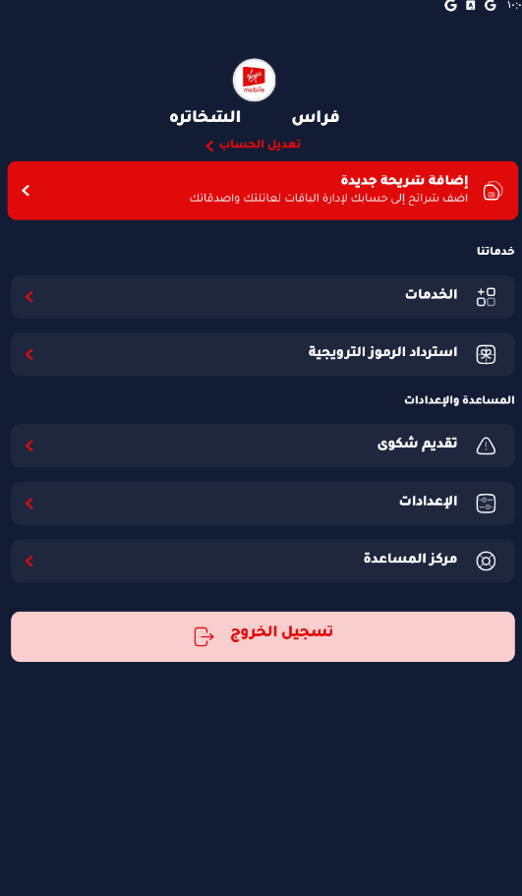
This section contains all additional account services and settings.
Key Features:
- SIM Management: Add and manage new Virgin Mobile SIM cards.
- Services: View or change service-related features.
- Promotional Code: Option to redeem discount or offer codes.
- Help & Support: Access help center, file complaints, and change app settings.
- Logout: Option to securely log out of the mobile application.

